**Cluster Maintenance**

## **OS Upgrades**

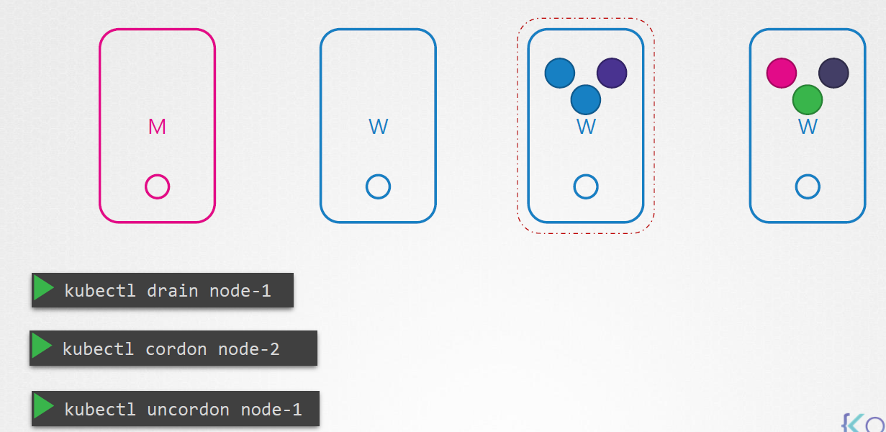

You have a cluster with a few nodes && pods serving the applications. What happens when one of the node goes down. Of course the pod on them are not accessible. Now depending upon how you deployed those PODs your user might me impacted.

For example, since you have multiple replicas of the blue pod, the users accessing the blue application are not impacted as they are being served through the other blue pods that online.

However users accessing the green pod are impacted as that was the only pod running the green application. Now what does k8 do in this case ??

If the node came back online immedeltly then the kubectl process starts and pods come back online. However if the node was down for more than 5 min then the pods are terminated from that node. Well Kubernetes considers them as dead. If the PODS where part of a replicaset then they are recreated on other nodes. The time it waits for a pod to come back online is known as the **pod eviction timeout and** set on controller manager with default value of 5 min.

So whenever a node goes offline , the master node waits for upto 5 mins before considering the node is dead. When the nodes comes back online after pod eviction timeout it comes up blank without any pods scheduled . Since the blue pods was part of replicaset it had a new pod created on another node. However since the green pod was not pat of the replica set its gone.

Thus if you have maintenance tasks to tbe performed on a node, if you know that the workloads running on the Node have other replcias && if its ok that they go down for a short period of time. And if you are sure the node wll come back online within five min you can make a quick upgrade and reboot.

However if you are not sure , there is safer way to do it. You can purposefully drain the node of all the workloads so that the workloads are moved to other nodes. Well technically they are moved. When you drain the node, the pods are gracefully terminated from the node that they are on and recreatd on another node.

The node is also cordoned or marked as unschedulable. Meaning no pods can be scheduling on this node until you specifically remove the restriction. Now the pods are safe on the other nodes, you can reboot the first node. When it comes back online it is unscheduled. You need to Uncorden it, so the pod can be scheduled on it again. Note: The pods that were moved to the other nodes don’t automcatically fall back. If any if those pods were deleted or created new in the cluster then they would created on this node.

Apart from drain and uncordon, there is also another command called cordon.

**Codon** simply marks the node unschdeulable. Unlike drain it does not terminate or move the pods on the existing node. It simply make sure that new pods are not scheduled on that node.

## **Kubernetes Software Version**

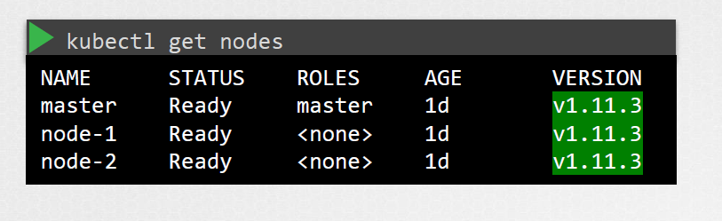

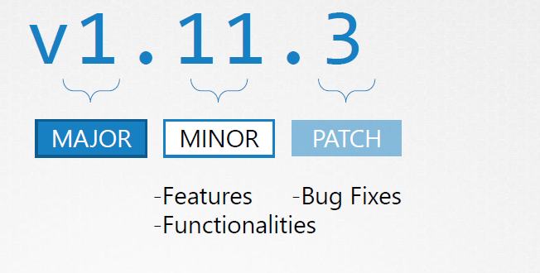

## **Cluster upgrade Process**

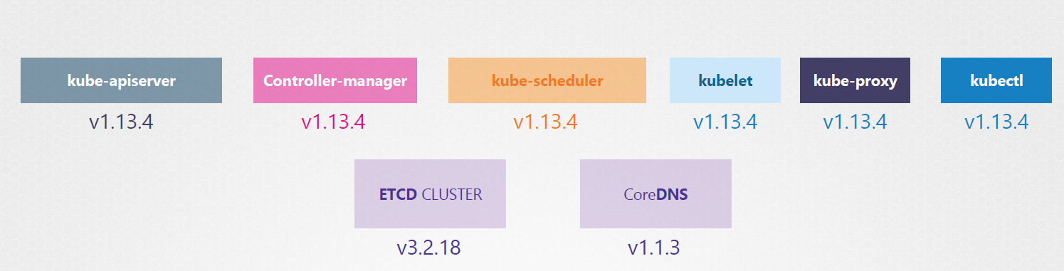

ETCD is third party component it can be dif version.

**Kubernetes core componenents**

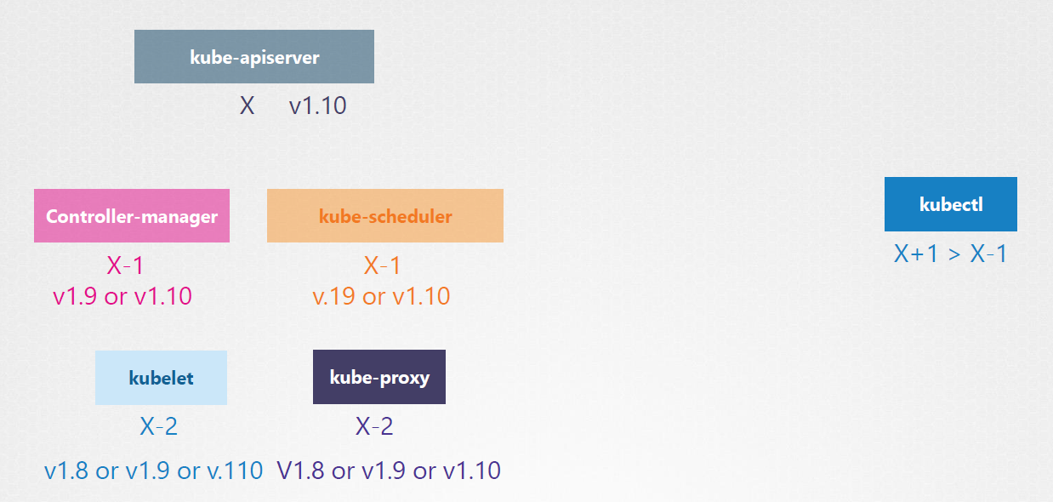

Is it mandatory for all these to have the same versions ?? NO

The components can be at dif release version since the Kube API is the primary component in the control plane and so none of the other components should ever be at a version higher than the KUBE API server. But this is not the case with KUBE CONTROL UITILITY it could be at 1.11 version higher than the API server 1.10 can be same version as API server or can be lower than API.

Control manager && scheduler can be at one version lower.

Kubelet && Kube schedulers can be at 2 versions lower.

We can upgrade component by component if required.

**So when you should upgragde ??**

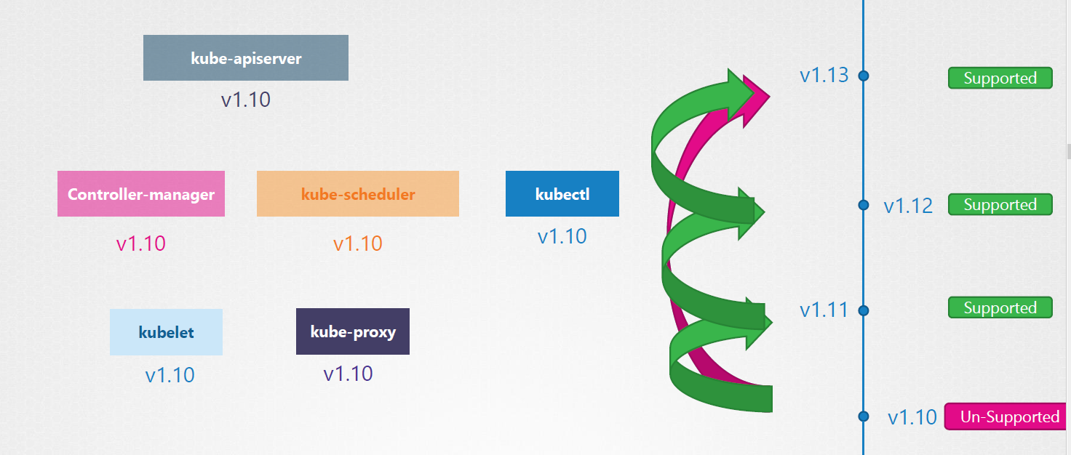

At any time Kubernetes supports only up to recent three minor version. So when 13 reelase only version 11 13 && 13 are supported. Do we upgrage from 10 to 13 directly ?? NO

Recommend approach is to upgrade one minor version at a time 10 to 11 to 12 to 13.

**The upgrade process is depends on how the cluster is set up.**

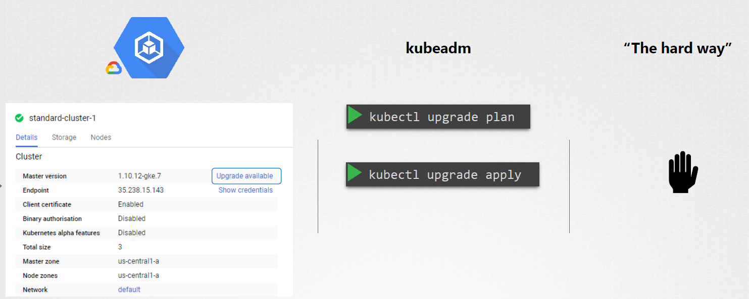

**Master Node upgrade**

1st upgrade your master nodes and then upgrade the worker nodes , while the master node is being upgraded , the control plane component such as API server , scheduler , controller goes down briefly . The master going down does not mean worker nodes and application are impacted. All workloads hosted on the worker nodes continue to serve users as normal.

Since the master is down, all management functions are down. You cannot access the cluster, cannot create new or delete the pod. If the pod is failed no new pod will get created. But as long as the nodes and the pods are up, your application should be up and users will not be impacted.

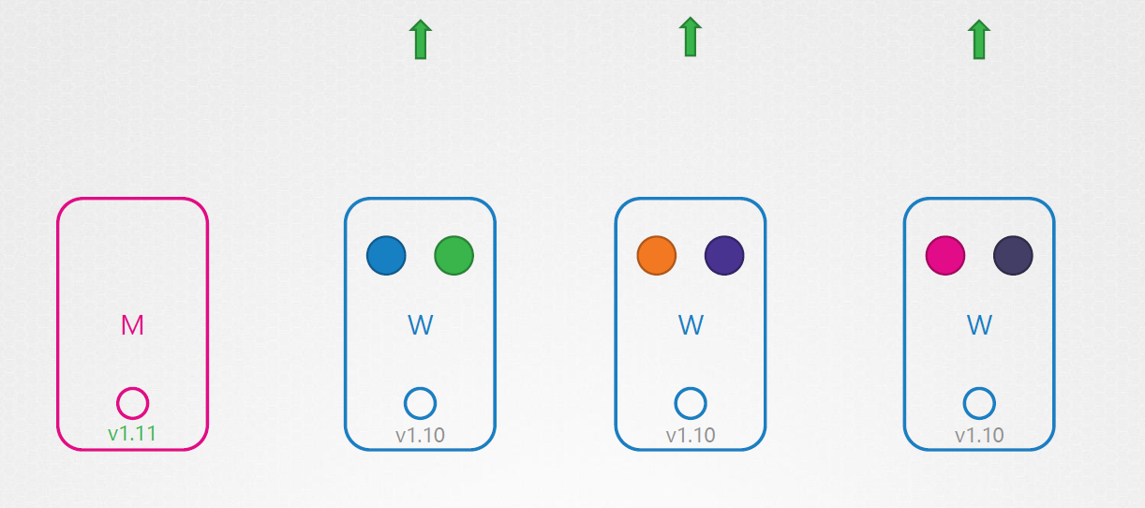

**Worker Nodes Upgrade process**

**Strategy one :: All at ONCE**

**Strategy TWO :: One at a Time**

**Strategy Three :: Add new nodes to the cluster with newer version**

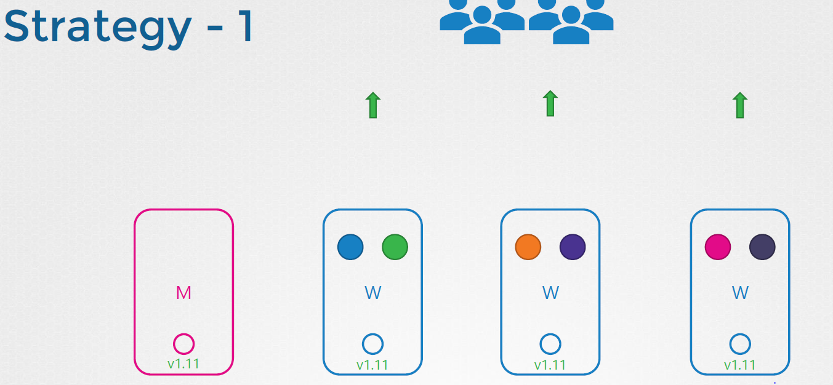

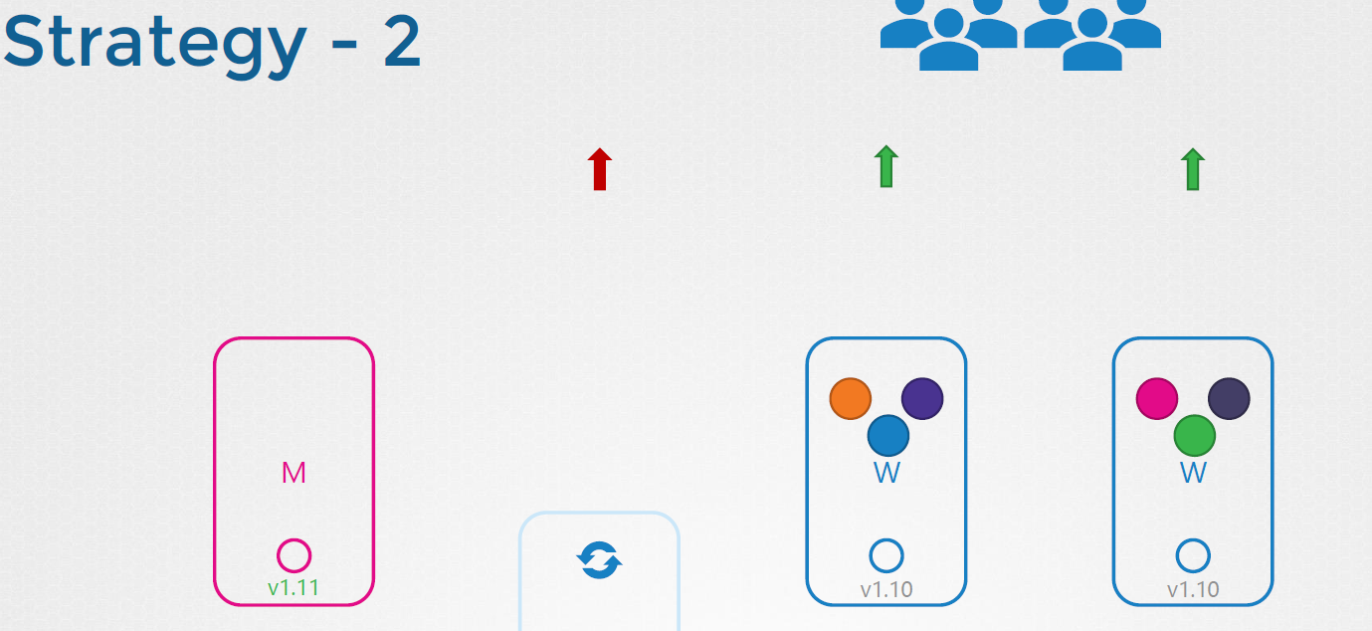

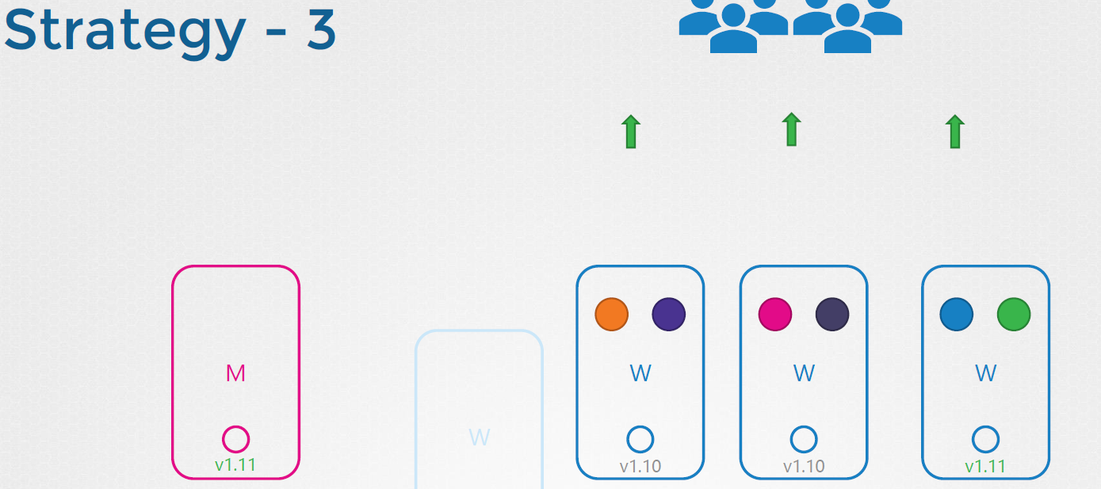

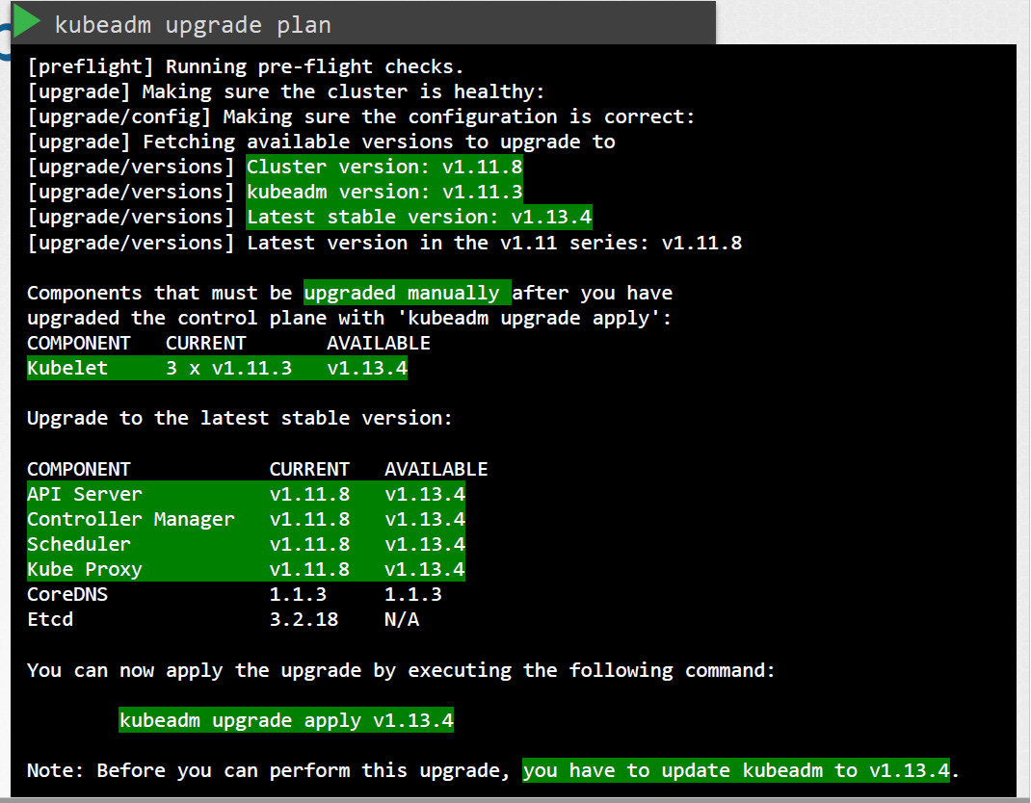

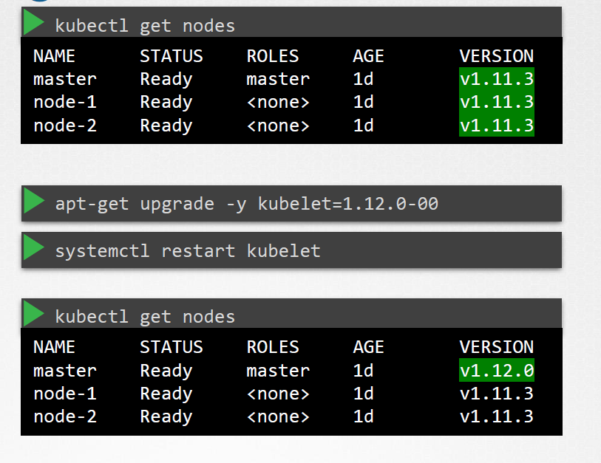

**WorkNodes Upgrade**

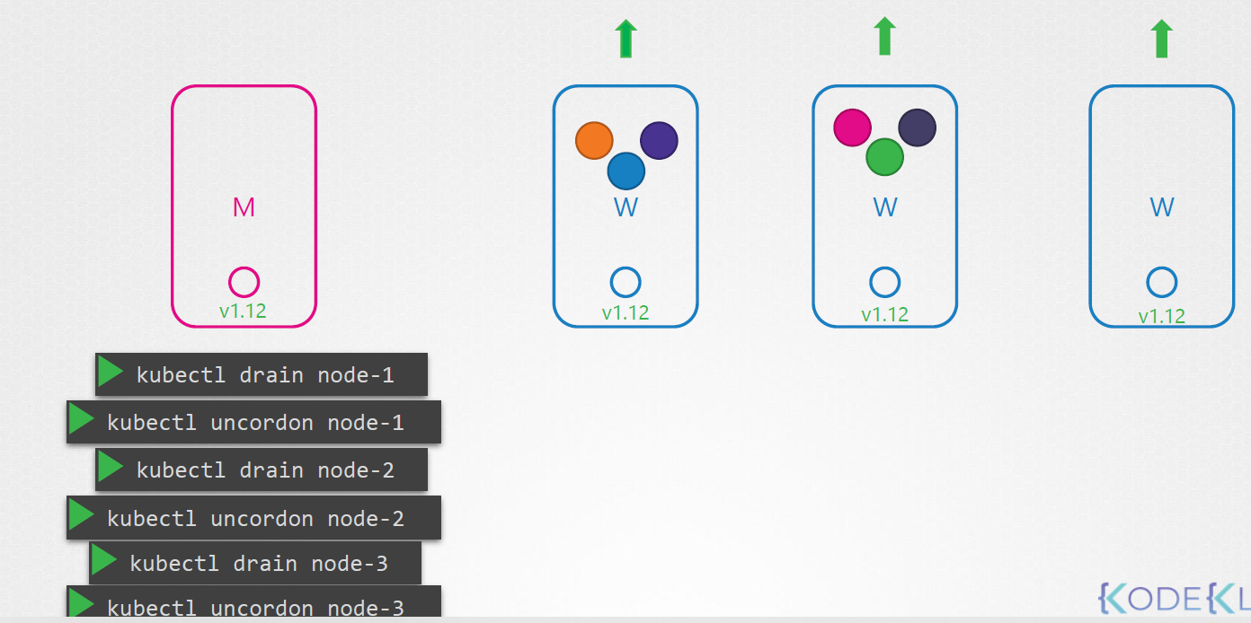

$ kubectl drain node-1

$ apt-get upgrade -y kubeadm=1.12.0-00

$ apt-get upgrade -y kubelet=1.12.0-00

$ kubeadm upgrade node config –kubelet-version v1.12.0

$ systemctl restart kubelet

$ kubectl ubncordon node-01

## **BackUP && Restore Methods**

